11th September 2019

**FIA WTCR Resumes in Asia after Summer break**

The FIA World Touring Car Cup, WTCR, which boasts Japanese Tyre manufacturer YOKOHAMA as its official tyre supplier, will return from its summer break at the Ningbo International Speedpark in Zhejiang province China, this coming weekend. With a length of 4kms and located 1400km south of Beijing, the circuit was inaugurated for WTCR in 2017, after an old quarry was transformed into a state of the art race circuit.

The leaders in the standings, the Argentinian Esteban Guerreri, Hungarian Norbert Michelisz and the current Champion, the Swedish Thed Björk, will face the odds of battling for the points against very tough and successful veteran drivers such as Yvan Muller, Gabrielle Tarquini, Tom Coronel and Thiago Monteiro as well as the national favourite Ma Qinghua. The Chinese driver has expressed conviction in having a good plan to overcome his more experienced competitors and the home crowd support should also become a positive factor for him throughout the race.

The WTCR Race of China begins with Free Practice 1 from 17h00-17h45 local time on Friday. Race 1 is from 15h40 on Saturday with Race 2 and Race 3 at 14h30 and 15h50 respectively.

**Current standings;**

Esteban Guerrieri 231

Norbert Michelisz 207

Thed Björk 181

Nestor Girolami 177

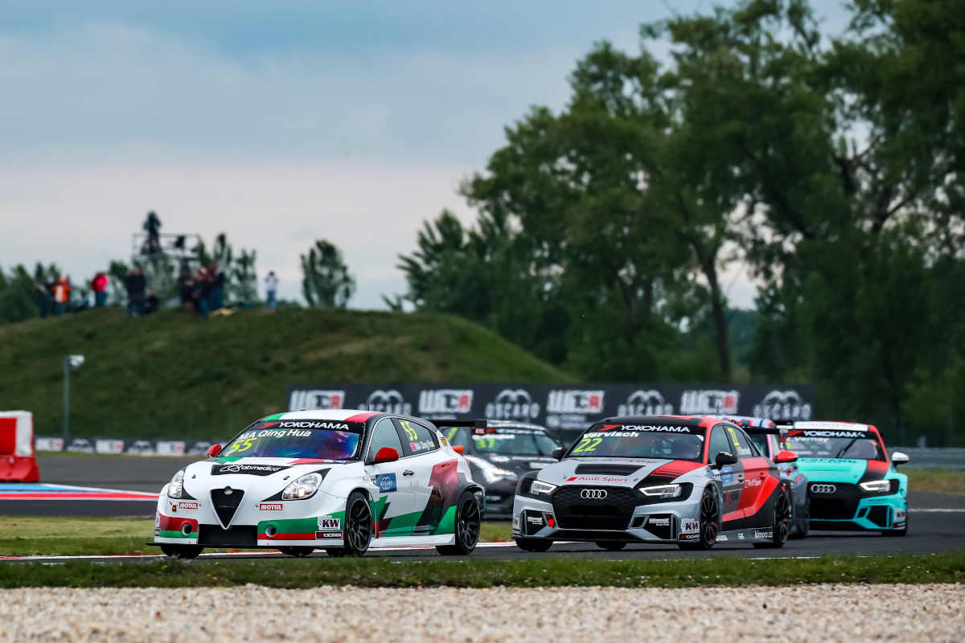

*Ma Qinghua ready for Ningbo Photo Marcel langer DPPI*

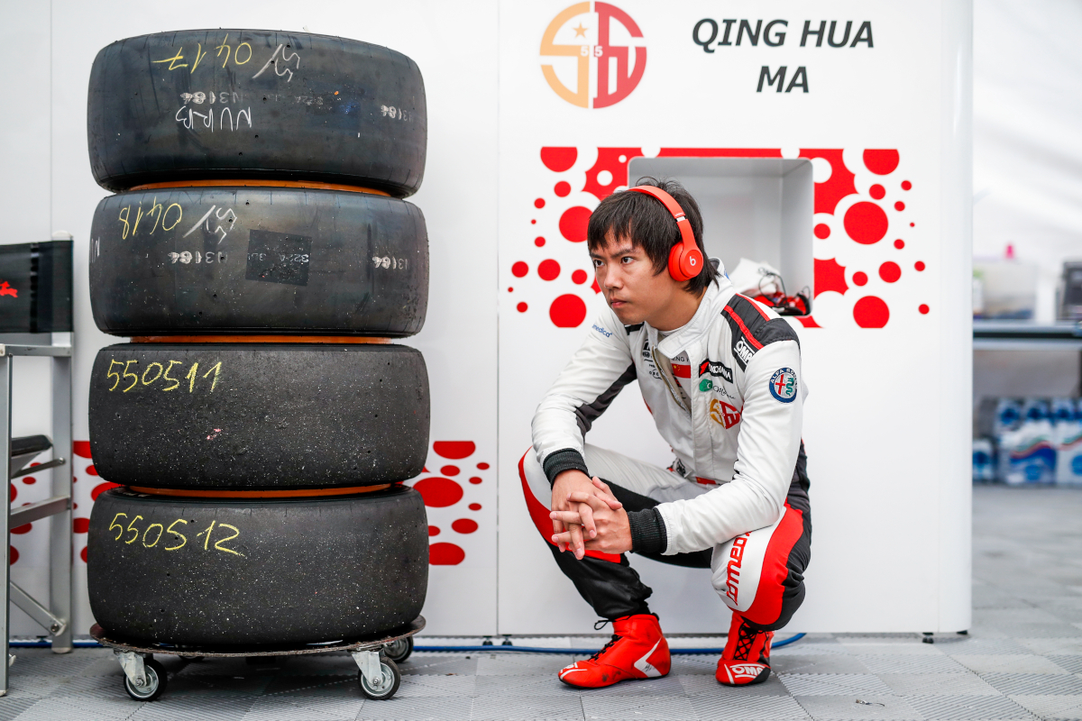

*05-Ma-Qinghua checks the tires carefully photo Florent Gooden DPPI*